Başkent Üniveristesi
Elektrik Elektronik Müh. Bölümü
EEM312 - Sayısal Elektronik
Yazılım Laboratuvarı

Rapor

Tarih : 18 Nisan 2006

Deney Adı : CMOS tersleyici karakteristiği
Deney No : Y3
Öğrenci Adı : Mustafa Baran Kızıltan
Numara : 20394095
Deney Grubu : A
Deney Tarihi : 5 Nisan 2006

1.

a
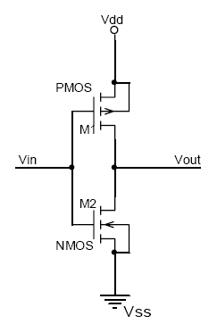
*Baran a
.MODEL MOSN NMOS LEVEL=2 LD=0.15U TOX=200.0E-10
+ NSUB=5.36726E+15 VTO=0.743469 KP=8.00059E-05 GAMMA=0.543
+ PHI=0.6 U0=655.881 UEXP=0.157282 UCRIT=31443.8
+ DELTA=2.39824 VMAX=55260.9 XJ=0.25U LAMBDA=0.0367072
+ NFS=1E+12 NEFF=1.001 NSS=1E+11 TPG=1.0 RSH=70.00
+ CGDO=4.3E-10 CGSO=4.3E-10 CJ=0.0003 MJ=0.6585
+ CJSW=8.0E-10 MJSW=0.2402 PB=0.58

VDD 3 0 DC 3.1
R1 3 2 100K
VIN 1 0 pulse (0 3.1 0 1n 1n 5n 10n)

M1 2 1 0 0 MOSN W=1.8u L=1.2u NRS=0.333 NRD=0.333
+ AD=6.5p PD=9.0u AS=6.5p PS=9.0u
C1 2 0 1f
.control
dc VIN 0 3.1 0.01
plot V(2) vs V(1)
.endc
.end
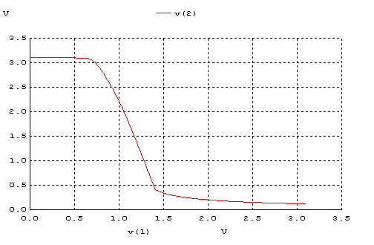

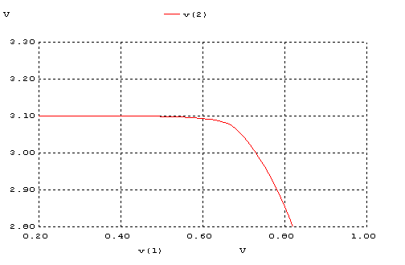
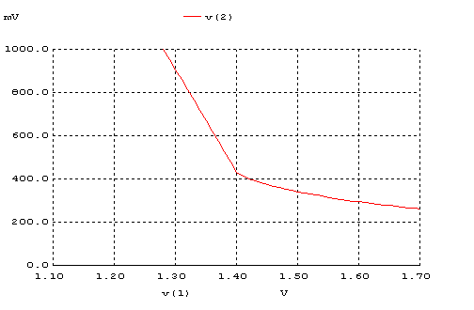

b.

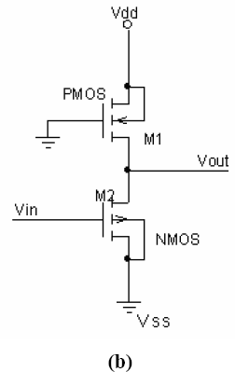
*Baran b
.MODEL MOSN NMOS LEVEL=2 LD=0.15U TOX=200.0E-10
+ NSUB=5. 36726E+15 VTO=0.743469 KP=8.00059E-05 GAMMA=0.543
+ PHI=0.6 U0=655.881 UEXP=0.157282 UCRIT=31443.8
+ DELTA=2.39824 VMAX=55260.9 XJ=0.25U LAMBDA=0.0367072
+ NFS=1E+12 NEFF=1.001 NSS=1E+11 TPG=1.0 RSH=70.00
+ CGDO=4.3E-10 CGSO=4.3E-10 CJ=0.0003 MJ=0.6585
+ CJSW=8.0E-10 MJSW=0.2402 PB=0.58

.MODEL MOSP PMOS LEVEL=2 LD=0.15U TOX=200.0E-10
+ NSUB=4.3318E+15 VTO=-0.738861 KP=2.70E-05 GAMMA=0.58
+ PHI=0.6 U0=261.977 UEXP=0.323932 UCRIT=65719.8
+ DELTA=1.79192 VMAX=25694 XJ=0.25U LAMBDA=0.0612279
+ NFS=1E+12 NEFF=1.001 NSS=1E+11 TPG=-1.0 RSH=120.6
+ CGDO=4.3E-10 CGSO=4.3E-10 CJ=0.0005 MJ=0.5052
+ CJSW=1.349E-10 MJSW=0.2417 PB=0.64

*eleman bağlantıları

VDD 3 0 DC 3.1
VIN 1 0 pulse (0 3.1 0 1n 1n 5n 10n)

M1 2 0 3 3 MOSP W=1.8u L=1.2u NRS=0.333 NRD=0.333
+ AD=6.5p PD=9.0u AS=6.5p PS=9.0u

M2 2 1 0 0 MOSN W=1.8u L=1.2u NRS=0.333 NRD=0.333
+ AD=6.5p PD=9.0u AS=6.5p PS=9.0u
C1 2 0 1f
.control
dc VIN 0 3.1 0.01
plot V(2) vs V(1)
.endc
.end

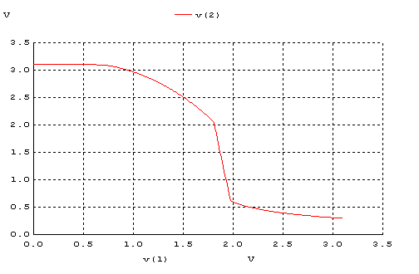

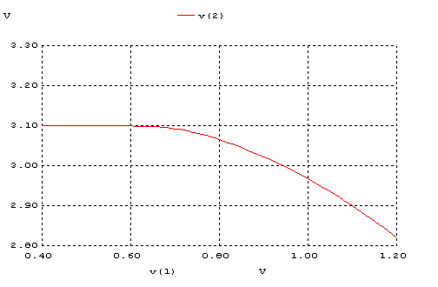
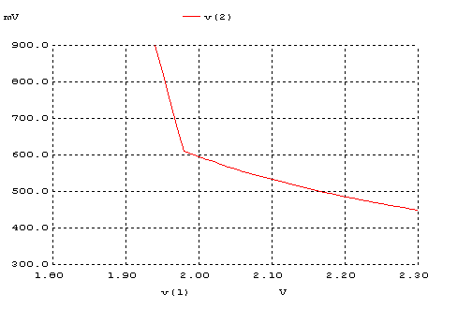

c.

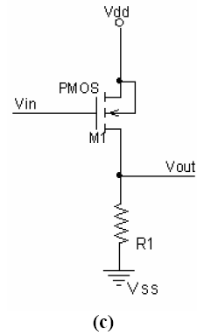
*baran c

.MODEL MOSP PMOS LEVEL=2 LD=0.15U TOX=200.0E-10
+ NSUB=4.3318E+15 VTO=-0.738861 KP=2.70E-05 GAMMA=0.58
+ PHI=0.6 U0=261.977 UEXP=0.323932 UCRIT=65719.8
+ DELTA=1.79192 VMAX=25694 XJ=0.25U LAMBDA=0.0612279
+ NFS=1E+12 NEFF=1.001 NSS=1E+11 TPG=-1.0 RSH=120.6
+ CGDO=4.3E-10 CGSO=4.3E-10 CJ=0.0005 MJ=0.5052
+ CJSW=1.349E-10 MJSW=0.2417 PB=0.64

*eleman bağlantıları

VDD 3 0 DC 3.1
VIN 1 0 pulse (0 3.1 0 1n 1n 5n 10n)

M1 2 1 3 3 MOSP W=1.8u L=1.2u NRS=0.333 NRD=0.333
+ AD=6.5p PD=9.0u AS=6.5p PS=9.0u
C1 2 0 1f
R1 2 0 100K
.control
dc VIN 0 3.1 0.01
plot V(2) vs V(1)
.endc
.end

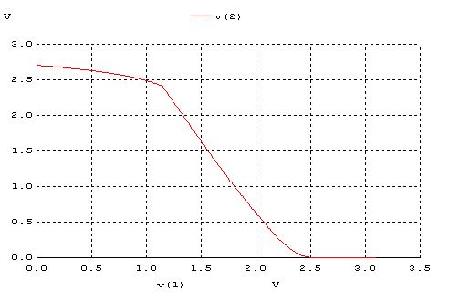
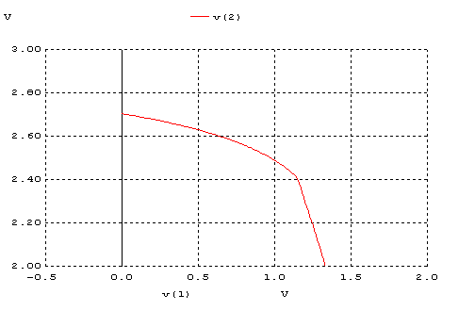
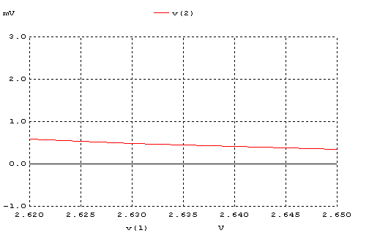

d.
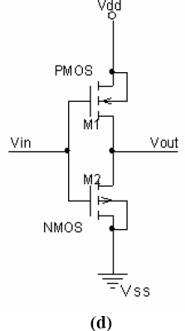
*baran d
.MODEL MOSN NMOS LEVEL=2 LD=0.15U TOX=200.0E-10
+ NSUB=5.36726E+15 VTO=0.743469 KP=8.00059E-05 GAMMA=0.543
+ PHI=0.6 U0=655.881 UEXP=0.157282 UCRIT=31443.8
+ DELTA=2.39824 VMAX=55260.9 XJ=0.25U LAMBDA=0.0367072
+ NFS=1E+12 NEFF=1.001 NSS=1E+11 TPG=1.0 RSH=70.00
+ CGDO=4.3E-10 CGSO=4.3E-10 CJ=0.0003 MJ=0.6585
+ CJSW=8.0E-10 MJSW=0.2402 PB=0.58

.MODEL MOSP PMOS LEVEL=2 LD=0.15U TOX=200.0E-10
+ NSUB=4.3318E+15 VTO=-0.738861 KP=2.70E-05 GAMMA=0.58
+ PHI=0.6 U0=261.977 UEXP=0.323932 UCRIT=65719.8
+ DELTA=1.79192 VMAX=25694 XJ=0.25U LAMBDA=0.0612279
+ NFS=1E+12 NEFF=1.001 NSS=1E+11 TPG=-1.0 RSH=120.6
+ CGDO=4.3E-10 CGSO=4.3E-10 CJ=0.0005 MJ=0.5052
+ CJSW=1.349E-10 MJSW=0.2417 PB=0.64

*eleman bağlantıları

VDD 3 0 DC 3.1
VIN 1 0 pulse (0 3.1 0 1n 1n 5n 10n)

M1 2 1 3 3 MOSP W=1.8u L=1.2u NRS=0.333 NRD=0.333
+ AD=6.5p PD=9.0u AS=6.5p PS=9.0u

M2 2 1 0 0 MOSN W=1.8u L=1.2u NRS=0.333 NRD=0.333
+ AD=6.5p PD=9.0u AS=6.5p PS=9.0u
C1 2 0 1f
.control
dc VIN 0 3.1 0.01
plot V(2) vs V(1)
.endc
.end

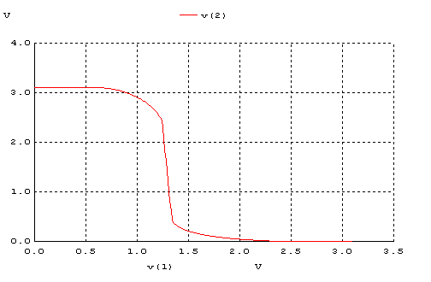
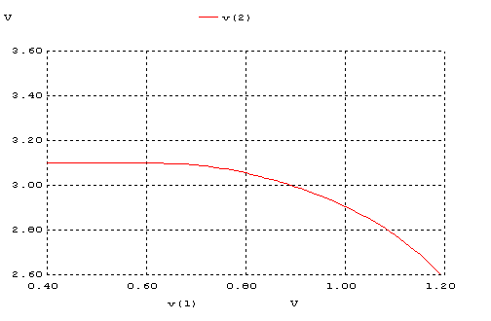
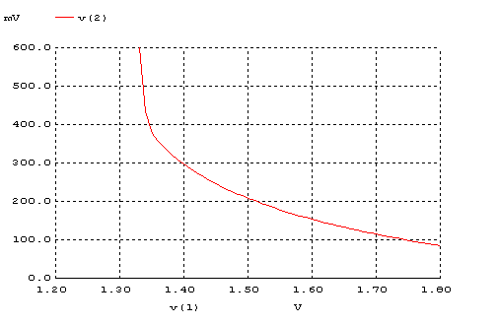
 | VOH | VOL | VIH | VIL | VM | NMH | NML
(a) | 3,1 V | 0,3 V | 1,3 V | 0,6 V | 1,26 V | 1,8 V | 0,3 V
(b) | 3,1 V | 0,5 V | 2,0 V | 1,5 V | 1,7 V | 1,1 V | 1 V
(c) | 2,75 V | 0 V | 2,3 V | 1,3 V | 1,5 V | 0,45 V | 1,3 V
(d) | 3,1 V | 0,15 V | 1,3 V | 1,15 V | 1,38 V | 1,8 V | 1 V
Tablo 1 – DC Analiz Sonuçları

2.
a
*bara-transient a
.MODEL MOSN NMOS LEVEL=2 LD=0.15U TOX=200.0E-10
+ NSUB=5.36726E+15 VTO=0.743469 KP=8.00059E-05 GAMMA=0.543
+ PHI=0.6 U0=655.881 UEXP=0.157282 UCRIT=31443.8
+ DELTA=2.39824 VMAX=55260.9 XJ=0.25U LAMBDA=0.0367072
+ NFS=1E+12 NEFF=1.001 NSS=1E+11 TPG=1.0 RSH=70.00
+ CGDO=4.3E-10 CGSO=4.3E-10 CJ=0.0003 MJ=0.6585
+ CJSW=8.0E-10 MJSW=0.2402 PB=0.58

*eleman bağlantıları

VDD 3 0 DC 3.1
R1 3 2 100K
VIN 1 0 pulse (0 3.1 0 1n 1n 5n 10n)

M1 2 1 0 0 MOSN W=1.8u L=1.2u NRS=0.333 NRD=0.333
+ AD=6.5p PD=9.0u AS=6.5p PS=9.0u
C1 2 0 1f
.control
tran 1p 20ns
plot V(2) V(1)
.endc
.end

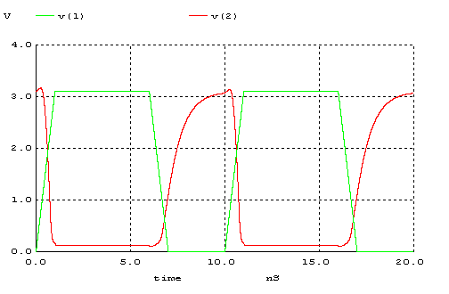

tpHL
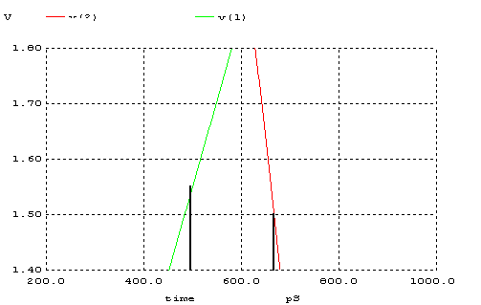
tpLH
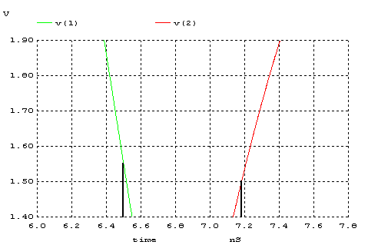

tf

%90
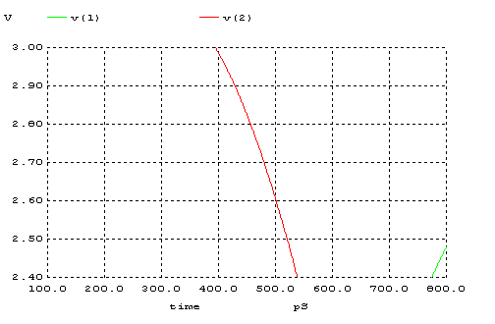

%10
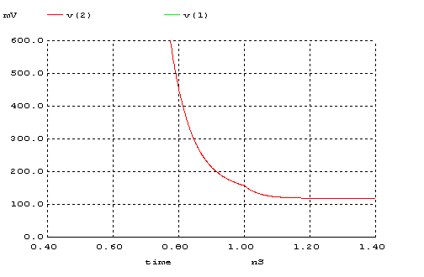

Tr

%90
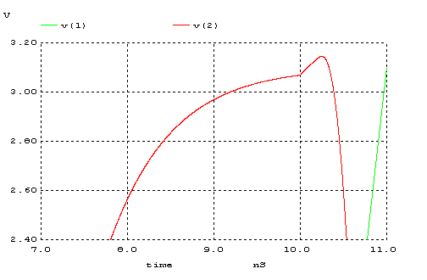

%10
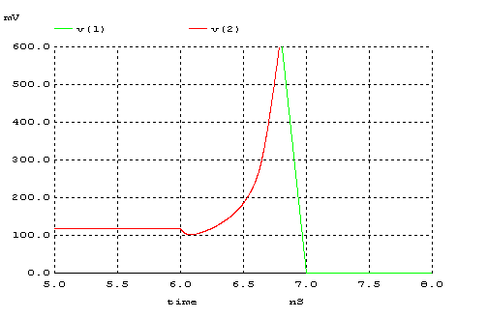

b.
*baran-transient b
.MODEL MOSN NMOS LEVEL=2 LD=0.15U TOX=200.0E-10
+ NSUB=5.36726E+15 VTO=0.743469 KP=8.00059E-05 GAMMA=0.543
+ PHI=0.6 U0=655.881 UEXP=0.157282 UCRIT=31443.8
+ DELTA=2.39824 VMAX=55260.9 XJ=0.25U LAMBDA=0.0367072
+ NFS=1E+12 NEFF=1.001 NSS=1E+11 TPG=1.0 RSH=70.00
+ CGDO=4.3E-10 CGSO=4.3E-10 CJ=0.0003 MJ=0.6585
+ CJSW=8.0E-10 MJSW=0.2402 PB=0.58

.MODEL MOSP PMOS LEVEL=2 LD=0.15U TOX=200.0E-10
+ NSUB=4.3318E+15 VTO=-0.738861 KP=2.70E-05 GAMMA=0.58
+ PHI=0.6 U0=261.977 UEXP=0.323932 UCRIT=65719.8
+ DELTA=1.79192 VMAX=25694 XJ=0.25U LAMBDA=0.0612279
+ NFS=1E+12 NEFF=1.001 NSS=1E+11 TPG=-1.0 RSH=120.6
+ CGDO=4.3E-10 CGSO=4.3E-10 CJ=0.0005 MJ=0.5052
+ CJSW=1.349E-10 MJSW=0.2417 PB=0.64

VDD 3 0 DC 3.1
VIN 1 0 pulse (0 3.1 0 1n 1n 5n 10n)

M1 2 0 3 3 MOSP W=1.8u L=1.2u NRS=0.333 NRD=0.333
+ AD=6.5p PD=9.0u AS=6.5p PS=9.0u

M2 2 1 0 0 MOSN W=1.8u L=1.2u NRS=0.333 NRD=0.333
+ AD=6.5p PD=9.0u AS=6.5p PS=9.0u
C1 2 0 1f
.control
tran 1p 20ns
plot V(2) V(1)
.endc
.end

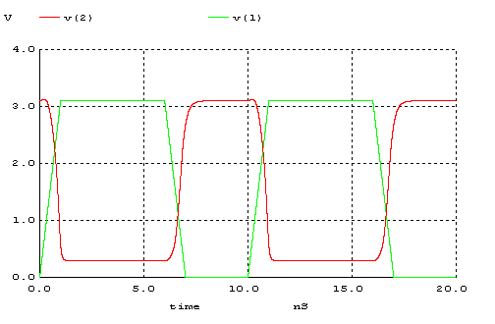

tpHL
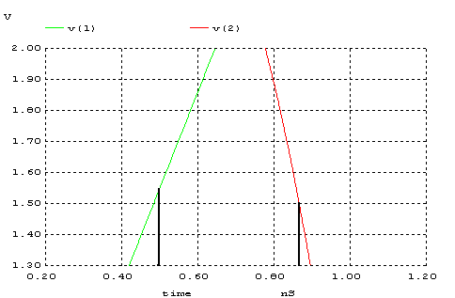

tpLH
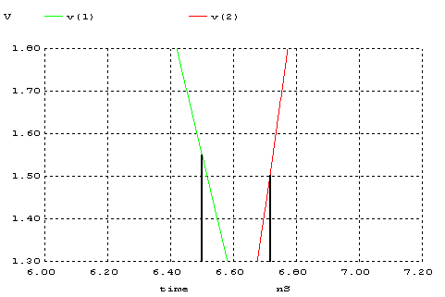

tf
%90
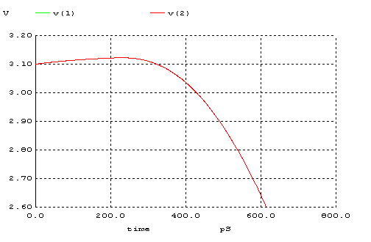

%10
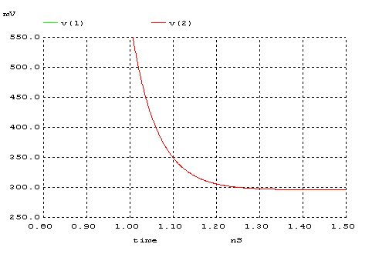

tr
%90
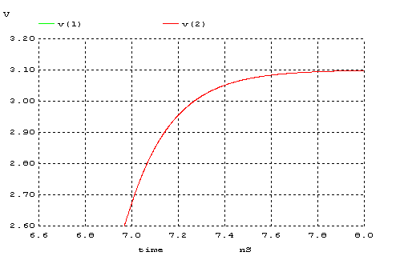

%10
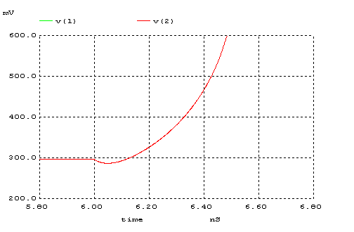

c.
*baran-transient c

.MODEL MOSP PMOS LEVEL=2 LD=0.15U TOX=200.0E-10
+ NSUB=4.3318E+15 VTO=-0.738861 KP=2.70E-05 GAMMA=0.58
+ PHI=0.6 U0=261.977 UEXP=0.323932 UCRIT=65719.8
+ DELTA=1.79192 VMAX=25694 XJ=0.25U LAMBDA=0.0612279
+ NFS=1E+12 NEFF=1.001 NSS=1E+11 TPG=-1.0 RSH=120.6
+ CGDO=4.3E-10 CGSO=4.3E-10 CJ=0.0005 MJ=0.5052
+ CJSW=1.349E-10 MJSW=0.2417 PB=0.64

*eleman bağlantıları

VDD 3 0 DC 3.1
VIN 1 0 pulse (0 3.1 0 1n 1n 5n 10n)

M1 2 1 3 3 MOSP W=1.8u L=1.2u NRS=0.333 NRD=0.333
+ AD=6.5p PD=9.0u AS=6.5p PS=9.0u
C1 2 0 1f
R1 2 0 100K
.control
tran 1p 20ns
plot V(2) V(1)
.endc
.end

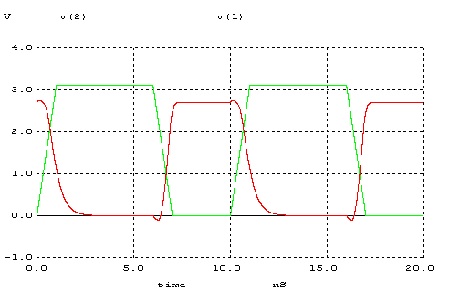

tpHL
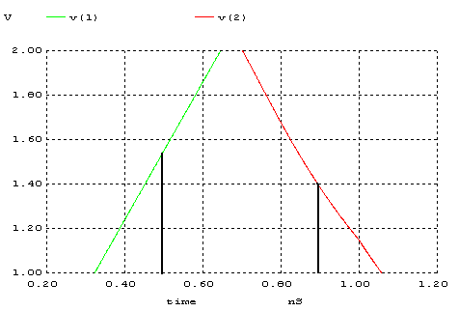

tpLH
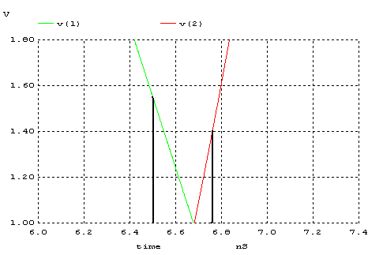

tr
%90
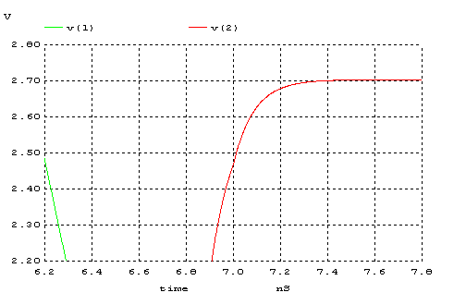

%10
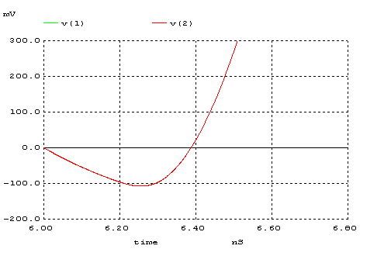

tf
%90
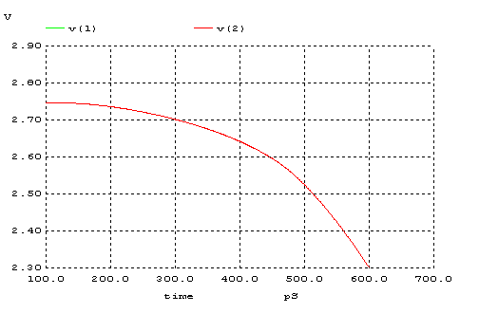

%10
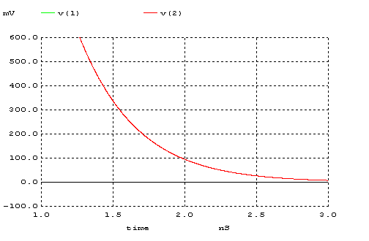

d.
*baran-transient d
.MODEL MOSN NMOS LEVEL=2 LD=0.15U TOX=200.0E-10
+ NSUB=5.36726E+15 VTO=0.743469 KP=8.00059E-05 GAMMA=0.543
+ PHI=0.6 U0=655.881 UEXP=0.157282 UCRIT=31443.8
+ DELTA=2.39824 VMAX=55260.9 XJ=0.25U LAMBDA=0.0367072
+ NFS=1E+12 NEFF=1.001 NSS=1E+11 TPG=1.0 RSH=70.00
+ CGDO=4.3E-10 CGSO=4.3E-10 CJ=0.0003 MJ=0.6585
+ CJSW=8.0E-10 MJSW=0.2402 PB=0.58

.MODEL MOSP PMOS LEVEL=2 LD=0.15U TOX=200.0E-10
+ NSUB=4.3318E+15 VTO=-0.738861 KP=2.70E-05 GAMMA=0.58
+ PHI=0.6 U0=261.977 UEXP=0.323932 UCRIT=65719.8
+ DELTA=1.79192 VMAX=25694 XJ=0.25U LAMBDA=0.0612279
+ NFS=1E+12 NEFF=1.001 NSS=1E+11 TPG=-1.0 RSH=120.6
+ CGDO=4.3E-10 CGSO=4.3E-10 CJ=0.0005 MJ=0.5052
+ CJSW=1.349E-10 MJSW=0.2417 PB=0.64

*eleman bağlantıları

VDD 3 0 DC 3.1
VIN 1 0 pulse (0 3.1 0 1n 1n 5n 10n)

M1 2 1 3 3 MOSP W=1.8u L=1.2u NRS=0.333 NRD=0.333
+ AD=6.5p PD=9.0u AS=6.5p PS=9.0u

M2 2 1 0 0 MOSN W=1.8u L=1.2u NRS=0.333 NRD=0.333
+ AD=6.5p PD=9.0u AS=6.5p PS=9.0u
C1 2 0 1f
.control
tran 1p 20ns
plot V(2) V(1)
.endc
.end
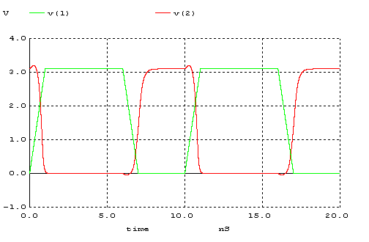
tpHL

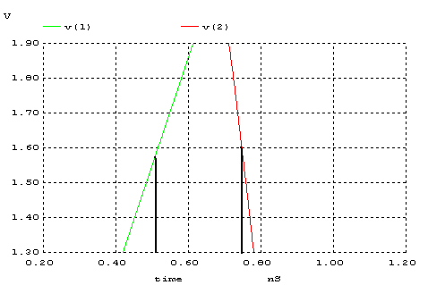

tpLH

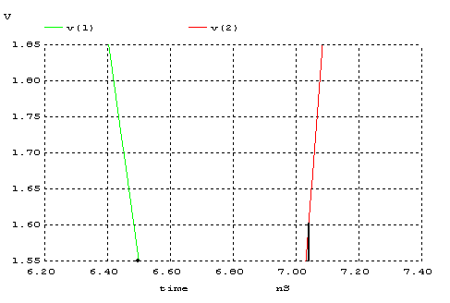

tf
%90
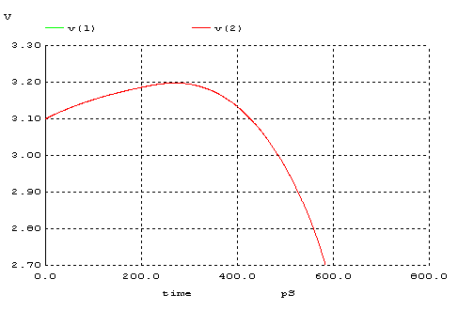

%10
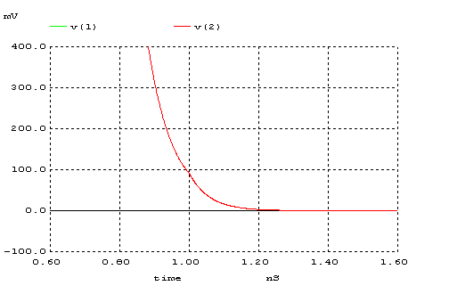

tr
%90
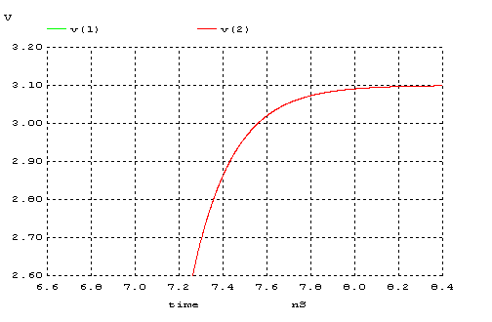

%10
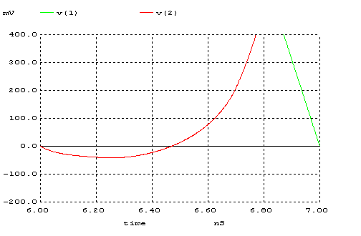

 | tr | tf | tPLH | tPHL | td
(a) | 2 ns | 0,4 ns | 0,8 ns | 0,2 ns | 0,5 ns
(b) | 0,4 ns | 0,4 ns | 0,2 ns | 0,4 ns | 0,3 ns
(c) | 1,5 ns | 3 ns | 0,3 ns | 0,3 ns | 0,3 ns
(d) | 0,4 ns | 0,3 ns | 0,5 ns | 0,3 ns | 0,4 ns
Tablo 2 – Dinamik durumu için ölçüm sonuçları

3.
- a şıkkındaki devre tersleyici için en iyi sonuçları vermektedir. Çünkü Vin Vdd-gnd arasında değerler alır.

Vin=Vdd iken NMOS on Çünkü Vg=Vdd Vs=0V Vgs=Vdd bu durumda Vgs>Vt dir
PMOS off olur. Çünkü Vg=Vdd Vs=Vdd Vgs=0V olur bu durumda channel oluşmaz ve PMOS çalışmaz.Bu durumda Vout=0V olur

Vin=0V iken NMOS off Çünkü Vg=0V Vs=0V Vgs=0V bu durumda channel oluşmaz ve NMOS çalışmaz.
PMOS on olur. Çünkü Vg=0v Vs=Vdd Vgs=-VddV olur bu durumda channel oluşur.
Bu durumda Vout=Vdd olur.
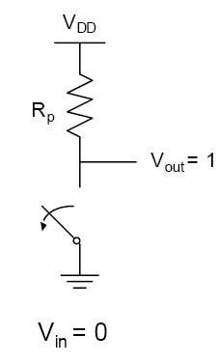
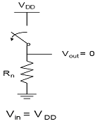

- Şıklarda verilen devrelerden b ve c şıklarındakiler simetriktir.
Diğer şıklar simetrik değildir. Çünkü VTC grafikleri birbirlerine uymamaktadır.

4.
*baran 4
.MODEL MOSN NMOS LEVEL=2 LD=0.15U TOX=200.0E-10
+ NSUB=5.36726E+15 VTO=0.743469 KP=8.00059E-05 GAMMA=0.543
+ PHI=0.6 U0=655.881 UEXP=0.157282 UCRIT=31443.8
+ DELTA=2.39824 VMAX=55260.9 XJ=0.25U LAMBDA=0.0367072
+ NFS=1E+12 NEFF=1.001 NSS=1E+11 TPG=1.0 RSH=70.00
+ CGDO=4.3E-10 CGSO=4.3E-10 CJ=0.0003 MJ=0.6585
+ CJSW=8.0E-10 MJSW=0.2402 PB=0.58

.MODEL MOSP PMOS LEVEL=2 LD=0.15U TOX=200.0E-10
+ NSUB=4.3318E+15 VTO=-0.738861 KP=2.70E-05 GAMMA=0.58
+ PHI=0.6 U0=261.977 UEXP=0.323932 UCRIT=65719.8
+ DELTA=1.79192 VMAX=25694 XJ=0.25U LAMBDA=0.0612279
+ NFS=1E+12 NEFF=1.001 NSS=1E+11 TPG=-1.0 RSH=120.6
+ CGDO=4.3E-10 CGSO=4.3E-10 CJ=0.0005 MJ=0.5052
+ CJSW=1.349E-10 MJSW=0.2417 PB=0.64

VDD 3 0 DC 3.1
VIN 1 0 pulse (0 3.1 0 1n 1n 5n 10n)

M1 2 1 3 3 MOSP W=5.4u L=1.2u NRS=0.111 NRD=0.111
+ AD=16.2p PD=11.4u AS=16.2p PS=11.4u

M2 2 1 0 0 MOSN W=1.8u L=1.2u NRS=0.333 NRD=0.333
+ AD=6.5p PD=9.0u AS=6.5p PS=9.0u
.control
dc VIN 0 3.1 0.01
plot V(2) vs V(1)
.endc
.end
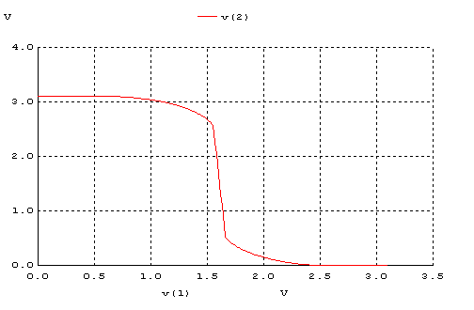
VOH | VOL | VIH | VIL | VM | NMH | NML
3,1 V | 0 V | 1,4 V | 1,7 V | 1,6 V | 1,7 V | 1,7 V

1 soruda 1,38 V olan VM değeri PMOS direncini değiştirince 1,6 V değerine çıkmıştır. Çünkü PMOS’un W/L oranını 3 katına çıkardık ve PMOS’un direnci 3 kat azaldı.

TRANSIENT ANALYSIS
*baran-transient 4
.MODEL MOSN NMOS LEVEL=2 LD=0.15U TOX=200.0E-10
+ NSUB=5.36726E+15 VTO=0.743469 KP=8.00059E-05 GAMMA=0.543
+ PHI=0.6 U0=655.881 UEXP=0.157282 UCRIT=31443.8
+ DELTA=2.39824 VMAX=55260.9 XJ=0.25U LAMBDA=0.0367072
+ NFS=1E+12 NEFF=1.001 NSS=1E+11 TPG=1.0 RSH=70.00
+ CGDO=4.3E-10 CGSO=4.3E-10 CJ=0.0003 MJ=0.6585
+ CJSW=8.0E-10 MJSW=0.2402 PB=0.58

.MODEL MOSP PMOS LEVEL=2 LD=0.15U TOX=200.0E-10
+ NSUB=4.3318E+15 VTO=-0.738861 KP=2.70E-05 GAMMA=0.58
+ PHI=0.6 U0=261.977 UEXP=0.323932 UCRIT=65719.8
+ DELTA=1.79192 VMAX=25694 XJ=0.25U LAMBDA=0.0612279
+ NFS=1E+12 NEFF=1.001 NSS=1E+11 TPG=-1.0 RSH=120.6
+ CGDO=4.3E-10 CGSO=4.3E-10 CJ=0.0005 MJ=0.5052
+ CJSW=1.349E-10 MJSW=0.2417 PB=0.64

*eleman bağlantıları

VDD 3 0 DC 3.1
VIN 1 0 pulse (0 3.1 0 1n 1n 5n 10n)

M1 2 1 3 3 MOSP W=5.4u L=1.2u NRS=0.111 NRD=0.111
+ AD=16.2p PD=11.4u AS=16.2p PS=11.4u

M2 2 1 0 0 MOSN W=1.8u L=1.2u NRS=0.333 NRD=0.333
+ AD=6.5p PD=9.0u AS=6.5p PS=9.0u
.control
tran 1p 20ns
plot V(2) V(1)
.endc
.end

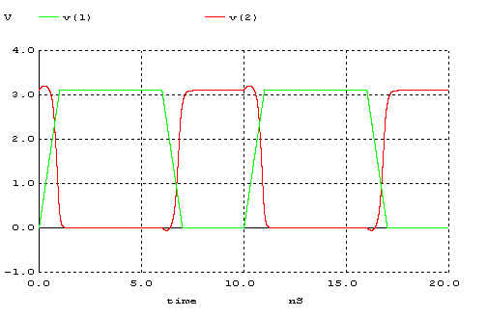

MOS ta W artıyor, L ise sabit kalıyor bu durumda switching treshold (W/L) artıyor. W/L oranı artarsa channel’ın direç özelliği azalır sonuç olarak gate kapasitansı artar. Bu durumda çıkışta yaşanan overshootlar daha belirgin hale gelmişitir.

